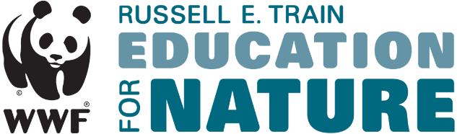

Employer Approval Form
WWF's Russell E. Train Education for Nature Program requires employer approval for all Professional Development Grant and Alumni Grant applicants. Professional Development Grants and Alumni Grants provide funding to individuals to attend short courses, conferences, and other non-degree training opportunities.
Please complete this form with the most up-to-date, accurate, and true information. The responses in this form will be used during the review process. Only an authorized signatory from the organization may submit this form.
Thank you for your cooperation.

Employer information
Name of organization:
City:
Country:
Date this organization was established:

Applicant information
Applicant's full name:
Applicant's job title
How long has this individual worked at this organization?
Name and title of applicant's supervisor:
Supervisor's email address:

Information regarding the training opportunity:
Name of proposed training course:
Is this course directly related to the applicant's current job responsibilities? If not, please explain why you are recommending that the individual attend the proposed training.
Please describe how the skills obtained during this training will be used by the applicant to improve the conservation outcomes of his/her projects or programs:
Please explain why this course is relevant to the applicant at this time in their career:

